
Maryland US Senate Race
Live/Text Benchmark Topline Results
Sample Size n=644
Method: Live/Text/Panel (324 Live + 173 Text +148 Online Panel)
Target Field Dates: May 8-10, 2024
Margin of Error at 95% Confidence Level: +/-3.9%
Today we are conducting scientific survey research in your area about the upcoming elections. We are not selling anything, and your responses will be kept confidential.
- First, are you or any member of your immediate family a member of the news media, a Public Relations company, or an active participant in any political campaign?
  - Yes 0%
  - No 100%

- Are you currently a registered voter in Maryland?
  - Yes 100%
  - No 0%

- How likely are you to vote in this year’s election for US Senate?
      - Extremely Likely 72.3%
      - Very Likely 15.0%
      - Somewhat Likely 7.8%
      - Not Very Likely 2.4%
      - Not Sure or Don’t Know 2.7%

- What would you say is the number one issue that will decide your vote for US Senate in this year’s election?
  - Illegal Immigration 8.8%
  - The Border 7.2%
  - Crime 6.9%
  - National Security 1.7%
  - Economy and Jobs 12.5%
  - Inflation 10.2%
  - Debt and Spending 2.7%
  - Abortion 12.0%
  - Other 30.5%
  - Don’t Know / Refused 7.4%
- What do you think is the number one threat to our national security?
  - China 6.7%
  - Russia 8.1%
  - Iran or Hamas 2.8%
  - Cyber Attacks 15.6%
  - The border 17.4%
  - A bad economy 11.7%
  - Terrorism 7.4%
  - Something else 26.5%
  - Don’t Know / Refused 3.8%
Now I am going to read you a list of names of people. After I read each one, please tell me if you have a favorable or unfavorable impression of that person. If I read one you have never heard of, just tell me and we’ll move on to the next one. The (first/next) one is…
- Joe Biden
- Very Favorable 31.8%
- Somewhat Favorable 23.9%
- Somewhat Unfavorable 9.5%
- Very Unfavorable 32.9%
- No Opinion 1.7%
- Don’t Know / Refused 0.3%
Total Favorable 55.7%
Total Unfavorable 42.3%

- Donald Trump
- Very Favorable 18.4%
- Somewhat Favorable 12.2%
- Somewhat Unfavorable 5.7%
- Very Unfavorable 61.6%
- No Opinion 1.7%
- Don’t Know / Refused 0.4%
Total Favorable 30.6%
Total Unfavorable 67.3%

- Larry Hogan
- Very Favorable 26.8%
- Somewhat Favorable 34.5%
- Somewhat Unfavorable 16.0%
- Very Unfavorable 15.0%
- No Opinion 6.2%
- Don’t Know / Refused 1.5%
Total Favorable 61.3%
Total Unfavorable 31.0%

- Do you think things in the United States are heading in the right direction or the wrong direction?
  - Right Direction 29.1%
  - Wrong Direction 59.3%
  - Don’t Know/Refused 11.6%

- What word would you use to describe Larry Hogan?
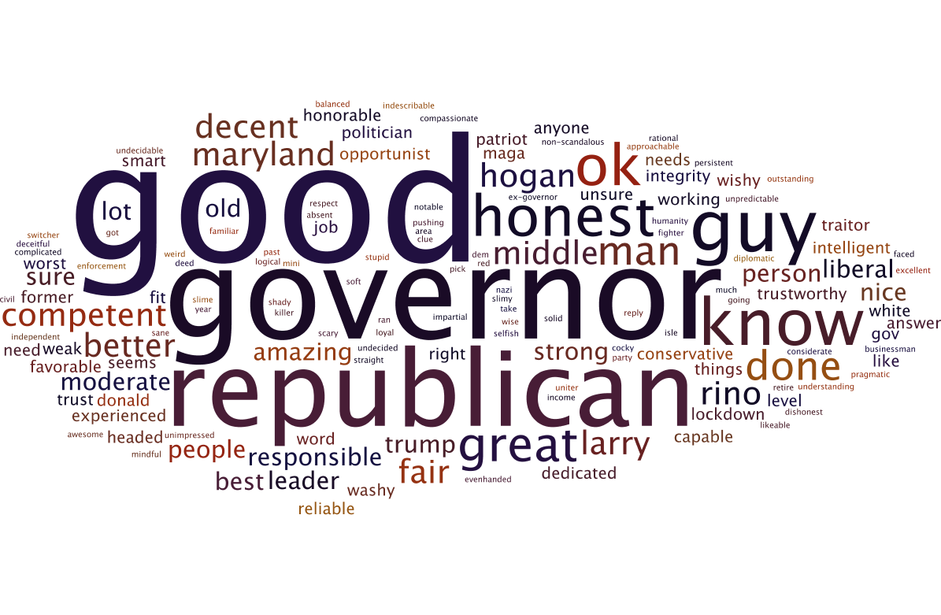
- Do you consider Larry Hogan to be
    - Very Conservative 7.0%
    - Somewhat Conservative 31.6%
    - Moderate 40.8%
    - Somewhat Liberal 9.2%
    - Very Liberal 4.5%
    - Don’t Know / Not Sure / Refused 6.8%
Total Conservative 38.6%
Total Moderate 40.8%
Total Liberal 13.8%

- Do you consider yourself to be <rotate choices 1-5 top to bottom/bottom to top>
- Very Conservative 13.2%
- Somewhat Conservative 15.0%
- Moderate 35.8%
- Somewhat Liberal 18.9%
- Very Liberal 15.6%
- Don’t Know / Not Sure / Refused 1.5%
Total Conservative 28.2%
Total Moderate 35.8%
Total Liberal 34.6%
Now changing gears a bit …
- How close do you think we are to the start of World War 3?
  - Not close at all 13.1%
  - Unlikely to start anytime soon 30.1%
  - Somewhat close 32.1%
  - Very close 17.1%
  - Don’t Know / Refused 7.6%

- Over the course of a regular week in your life, where would you most regularly see or hear news about government and politics?
- Fox News, Newsmax or OANN 11.7%
- CNN or MSNBC 20.7%
- Morning or evening broadcast TV news 20.2%
- Newspapers 6.9%
- Radio 6.2%
- Social media apps like Facebook or Twitter 12.1%
- YouTube 5.1%
- Google News, Apple News, or other 12.0%
news sites on the internet
- Don’t know / Refused 5.2%

- Who did you vote for in the 2020 Election for President?
  - Joe Biden 60.5%
  - Donald Trump 27.0%
  - Someone Else 4.3%
  - Didn’t Vote 5.0%
  - Don’t Know / Refused 3.2%
And, finally for demographic purposes only,
QGEN What is your gender?
- Female 55.3%
- Male 43.8%
- Don’t know / Refused 0.9%
QAGE What year were you born?
- 18-34 12.9%
- 35-54 30.7%
- 55-64 18.9%
- 65+ 35.9%
- Not Sure/Don’t Know 1.7%
QMAR What is your marital status?
- Single 24.2%
- Married 55.2%
- Divorced 8.7%
- Widowed 9.4%
- Don’t Know / Refused 2.6%
QETH What is your Ethnicity?
- White or Caucasian 59.7%
- Hispanic or Latino 2.0%
- Black or African American 29.4%
- Asian 1.4%
- Another not listed 3.3%
- Don’t Know / Refused 4.2%
QED What is the highest education level you achieved?
- Some or no college 42.0%
- Bachelor’s degree 28.7%
- Masters or Doctorate 24.8%
- Don’t Know / Refused 4.4%
QPAR What political party do you consider yourself affiliated with?
- Republican 26.6%
- Democrat 57.0%
- Other 14.7%
- Don’t Know / Refused 1.7%
QVHG Vote History (Not Asked/Coded from file)
- New Voter 2.7%
- 1 of 4 1.0%
- 2 of 4 10.2%
- 3 of 4 15.4%
- 4 of 4 47.6%
- Panelists 22.9%
QCO DMA (Not Asked/Coded from file)
- Baltimore 52.9%
- Pittsburgh 0.5%
- Salisbury 3.9%
- DC 42.8%

